|  |  |
| --- | --- |
| Date | 26 October 2022 |
| Team ID | PNT2022TMID15139 |
| Project Name | Smart Farmer - IoT Enabled Smart Farming Application |

**CREATE IDLE SHELL(PYTHON) SOFTWARE:**

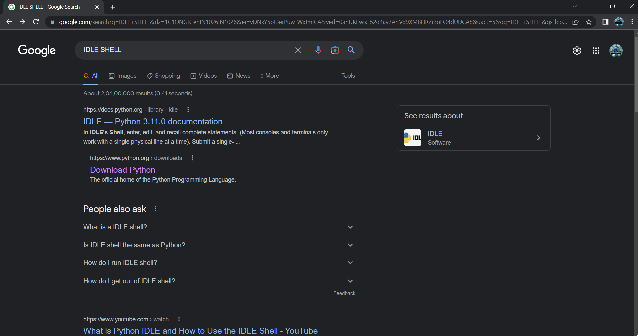

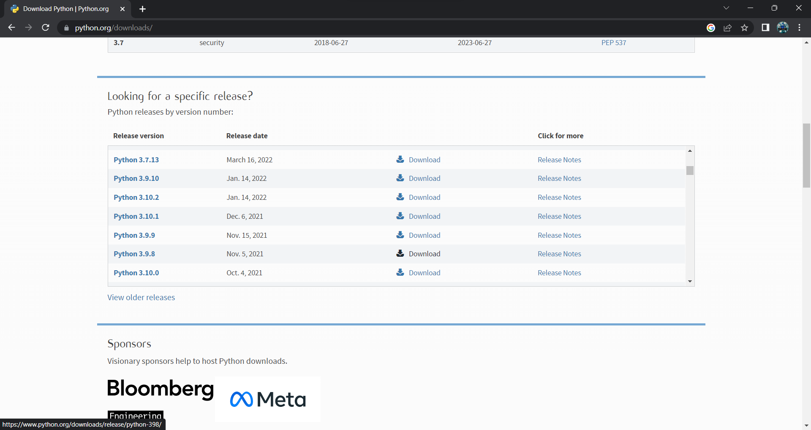

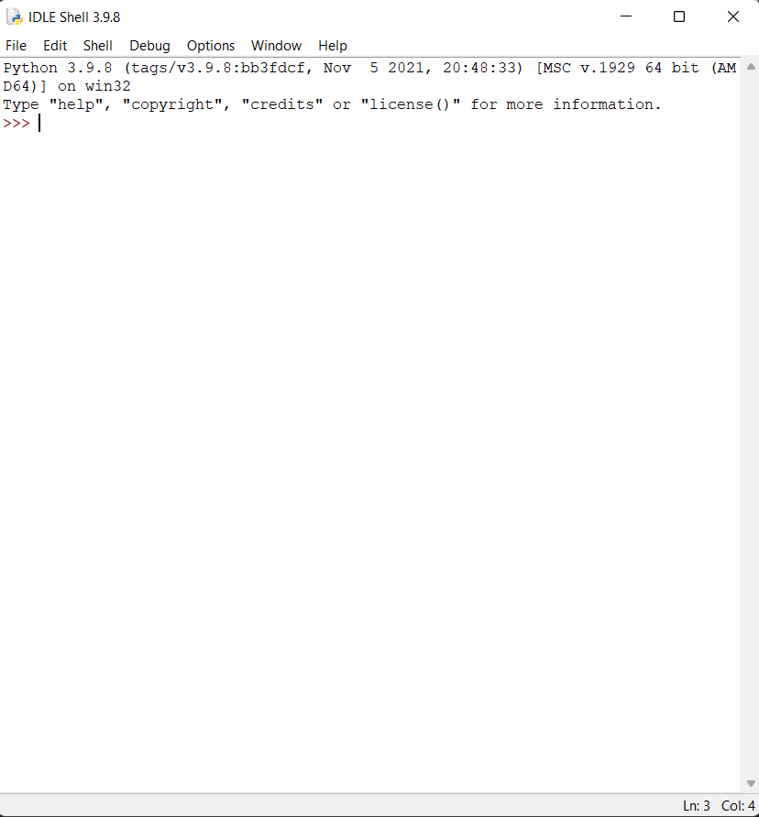

**CREATE NODE-RED SERVICE:**

**STEP 1: Login to IBM cloud and click Catalog**

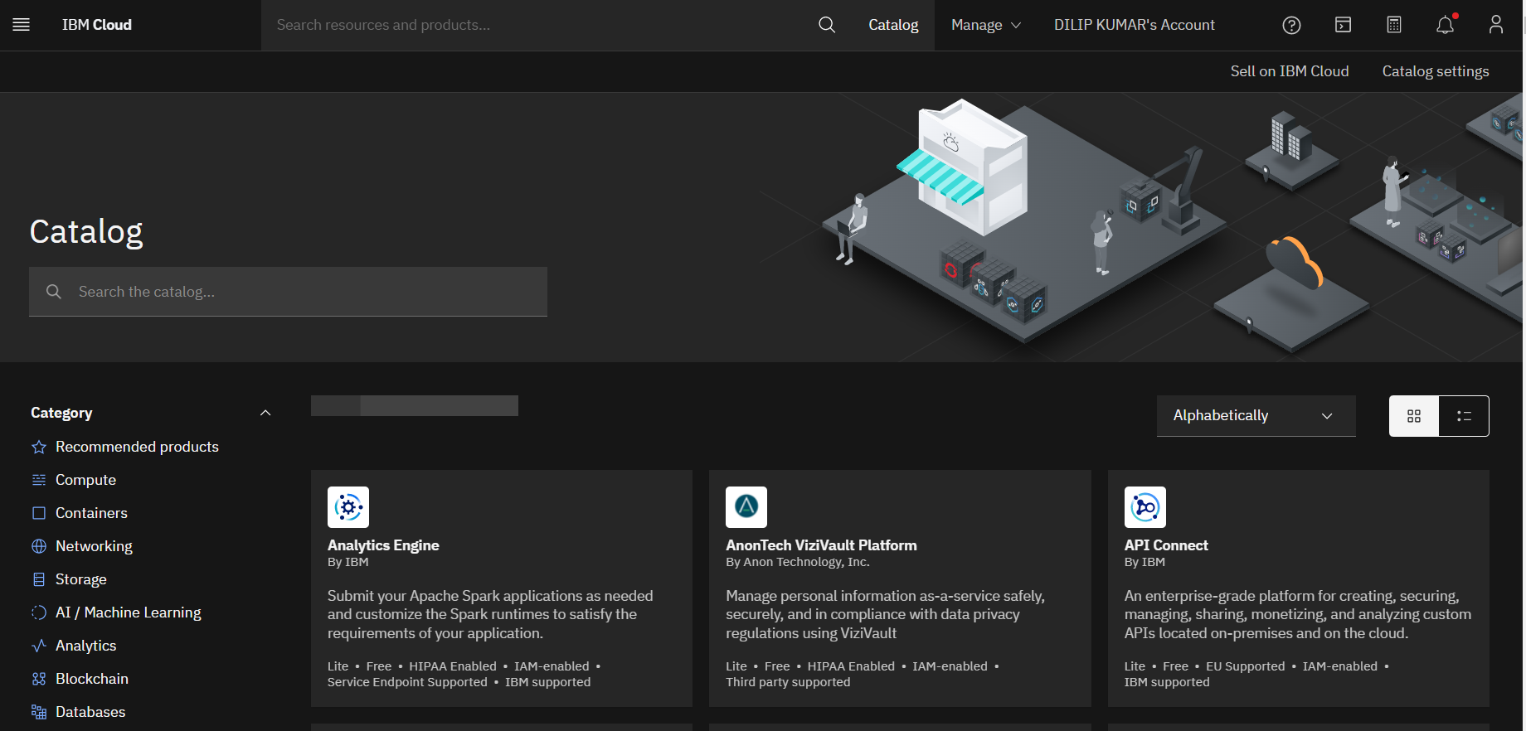

**STEP 2: Search NODE-RED**

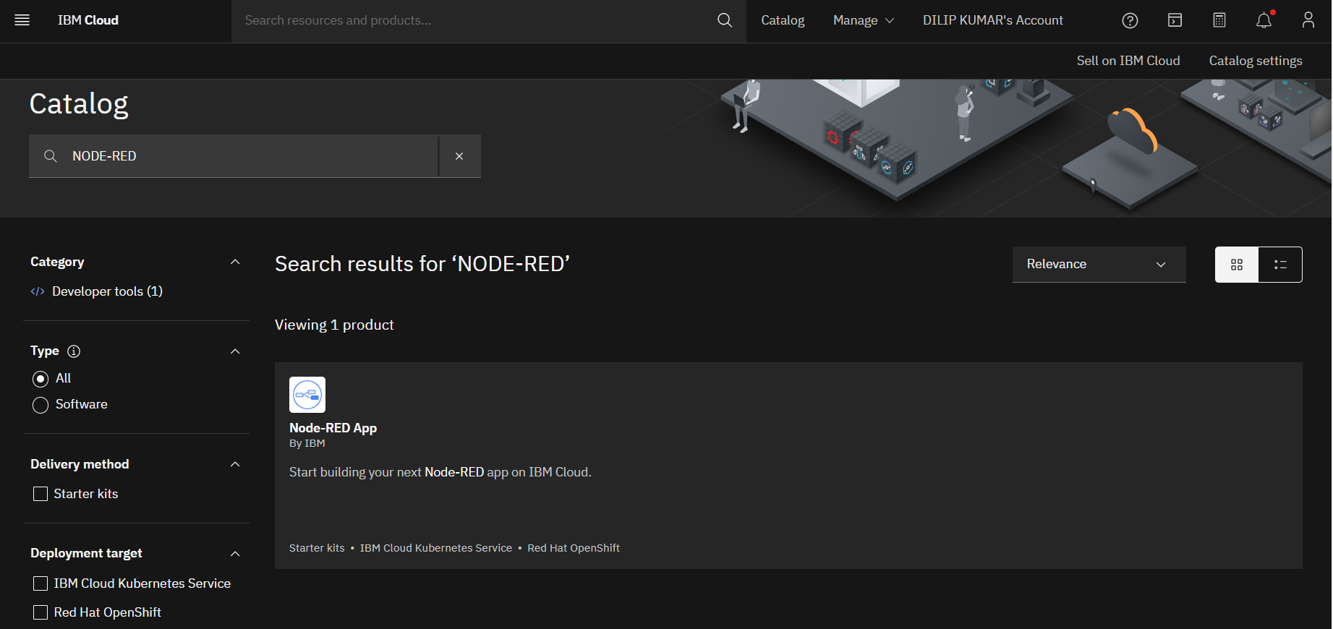

**STEP 3: Configure NODE-RED:**

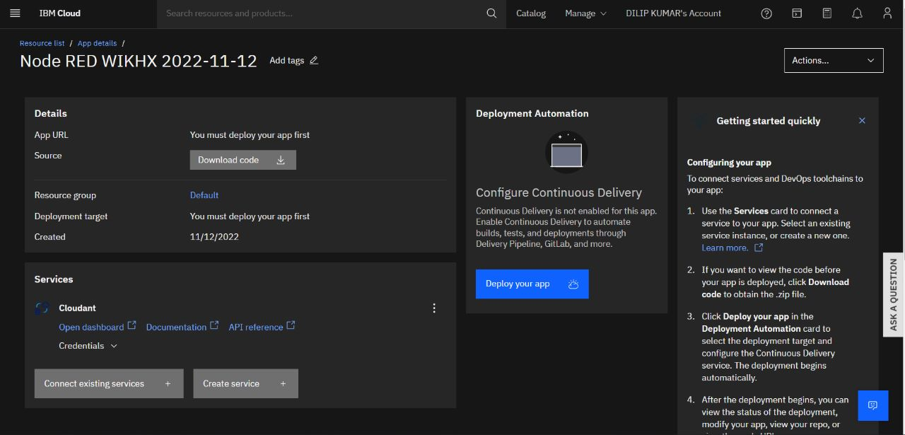

**STEP 4: Visit the NODE-RED App**

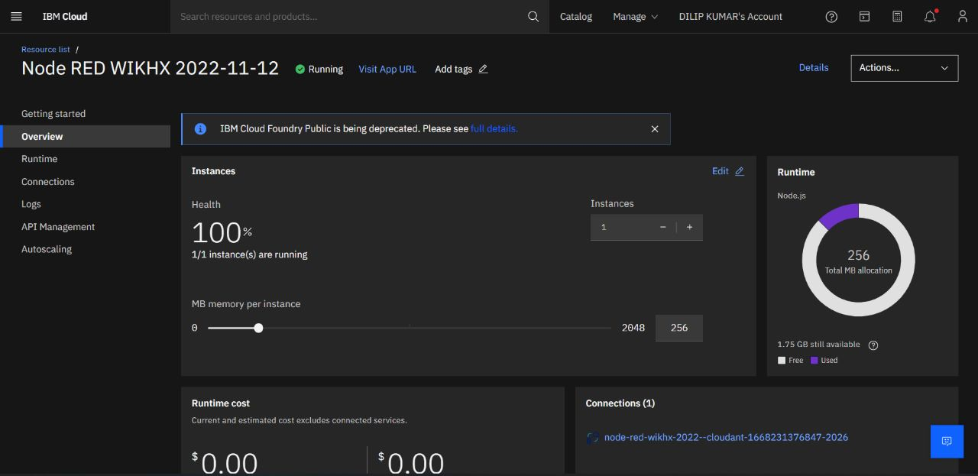

**STEP 5: Create the Node red app**

